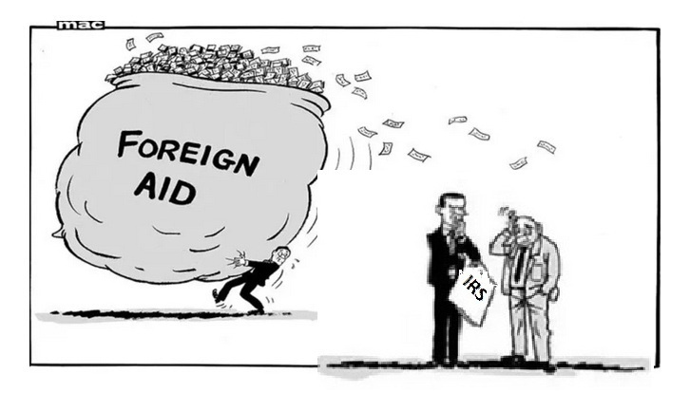
Foreign countries, especially China and Russia, have benefited from Anti-American Globalization in another way, foreign aid. For example, the US and other countries have given billions of dollars to China. Japan gave 32 billion dollars to China from 1984 to 2016. Why would Japan do that? Japan and China have had mutual animosity for thousands of years.
Also, from 2001 to 2003 the US gave over 5 billion dollars to China. Why would our government do that? That did lead to a Congressional hearing titled "Feeding the Dragon" but in spite of that, foreign aid to China continues to this day! Evidently we have the best government that money can buy, politicians can't all be that stupid. There has to be some organized clandestine activity behind these aid programs, corporate tax increases, and tariff decreases.
Here is one that you will not believe. Since the fall of the Soviet Union, December 1991, the United States has given over 20 billion dollars in foreign aid to Russia and 10 million dollars in 2020 according to: https://foreignassistance.gov/cd
REGULATIONS
Like high corporate taxes, regulations add to the cost of doing business in the United States.
In the early 1990s, thousands of printed circuit board manufactures were put out of business by environmental regulations. I had to order printed circuit boards from a company in Alberta Canada. An employee there said that their environmental agencies work with businesses to solve problems. In the US environmental agencies are predatory.
The compliance costs associated with EPA regulations under Obama numbered in the hundreds of billions and have grown by more than $50 billion in annual costs. Such high costs, especially those related to the energy sector, ripple throughout the economy, impacting GDP, killing thousands of jobs, and increasing the cost of consumer goods. (39)

